Class: 7S
Name: Chan Kam Chum (3) , Chan Wai Shan (6) ,
Chui Yeuk Chau (9) , Ho Mei Wah (10) , Hung Wing Tung (12)
Topic: Green Chemistry
Title: Interesterification using Lipozyme® TL IM

Introduction

Conventional chemical hydrogenation usually produces large amounts of trans-fats with many unwanted waste chemicals. Noticing of how much consumers concern about what they eat and what is written on food labels in recent years, many chemists put effort into the enzymatic interesterification for the production of trans-free margarine fats.

On June 20, 2005, the joint ADM and Novozymes teams, who created the method of enzymatic interesterification using Lipozyme® TL IM for producing trans-free margarine, received a 2005 Presidential Green Chemistry Challenge Award presented by Environmental Protection Agency in the United States.

The enzymatic interesterification using Lipozyme® TL IM is a competitive and clean technology for manufacture of margarines and shortenings. It is a process which makes use of enzymes (biological catalysts) to modify vegetable oils so as to avoid the formation of trans-fatty acids in the production of margarines with low cost.

Principles
There are three steps:
1. Pretreatment of oil
2. Use of catalyst: lipase
3. Deodorization

1. Pretreatment of oil

Impurities in the oil can inactivate the lipase, so it is important to bleach, dry, and degum incoming oil before the reaction.
The purpose of bleaching is to reduce the levels of pigments like carotenoids and chlorophyll. It also further removes contaminants that reduce the final product quality, such as residues of phosphatides, soaps, traces of metals, oxidation products, and proteins. These substances are removed by adsorption with activated clay and silica. If heavy polycyclic aromatic hydrocarbons are present, activated carbon can be used to remove them. The bleaching agent containing all these substances is separated by filtration.
The purpose of degumming is to remove most of the phosphatides, carbohydrates, proteins and traces of metals waxes. The crude oil is treated with water at around 100°C, which leads to hydration of those impurities. The hydrated material is then removed from the oil through precipitation.

2. Use of catalyst: lipase

A. Continuous fixed bed process

The oil passed through a packed column which holds the enzyme at a controlled flow rate. The time for the oil to contain in the column determines the degree of conversion. It allows the catalyst to be reused, and creates a limited amount of cross contamination

- Multiple fixed bed process

Multiple fixed bed process has different enzyme activity in each reactor. The multiple processes are usually conducted in series, and the average production is 1-2 kg IE oil per kg of enzyme per hour.
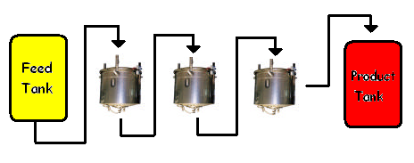
Reactor 1
Reactor 2
Reactor 3
The most common process is to pack the enzyme in a fixed bed reactor with the oil passing through the column in a downward flow. The immobilized enzyme must be packed uniformly in the fixed bed reactor to ensure good performance of the process because when trapped air is released, it affects the reactor efficiency. The enzyme can either be wet packed, as slurry suspended in oil or dry-packed followed by wetting with oil under vacuum.
This set-up requires minimal maintenance and very low equipment costs. Immobilized lipase is used to interesterify fatty acids on oils and fats.

Equation:
The lipase is 1, 3-specific, which rearranges the fatty acids in the 1- and 3- position. This leaves the fatty acid chain in the 2-position untouched, so as to produce a "more natural" oil.
For example:

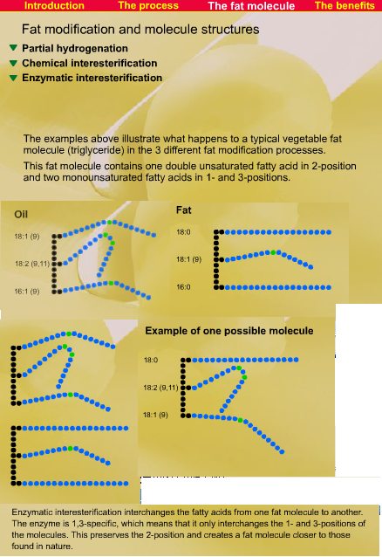

3. Deodorization

It is a simple vacuum steam distillation process that removes the relatively volatile components that cause undesirable colors and odors in fats and oils. This is feasible because of the great differences in volatility between these undesirable substances and the triglycerides. Deodorization reduces the level of free fatty acids and to remove odors, off-flavors and other volatile components such as pesticides and light polycyclic aromatic hydrocarbons by a stripping media. The process is carried out under vacuum (0.5 - 8 mbar) and at high temperatures, and use stripping media, such as steam or nitrogen, as those substances are usually volatile.

Possible Advantages

1. Replacing partially hydrogenated oils with interesterified products can have a huge positive impact on public health by reducing trans-fatty acids, which lead to increased serum levels of LDL cholesterol, resulting in atherosclerosis. Another benefit of the process is the increase in polyunsaturated fatty acids, which can reduce the bad cholesterol level in blood.

2. The enzymatic interesterification process uses no harsh chemicals, generates no waste water or solid waste and reduces the loss of edible oils. As one example, compared to partial hydrogenation, the ADM/Novozymes process has the potential to save 400 million pounds of soybean oil and eliminate 20 million pounds of sodium methoxide, 116 million pounds of soaps, 50 million pounds of bleaching clay, and 60 million gallons of water each year. This benefits the environment a lot.

3. Oils are processed under milder conditions so that nutrients in oil are better preserved.

Examples of products

Zero- and reduced-trans-fat vegetable oils, which can be used to make margarines, processed baked goods can be produced. Besides, shortenings as well as beef tallow and rapeseed oil blend can also be made.

