Modern buildings - Concrete
Concrete is a construction material composed of cement as well as other cementitious materials such as fly ash and slag cement, (generally a coarse aggregate such as gravel, limestone or granite, plus a fine aggregate such as sand), water and chemical admixtures.
Concrete solidifies and hardens after mixing with water and placement due to a chemical process known as hydration. The water reacts with the cement, which bonds the other components together, eventually creating a stone-like material.

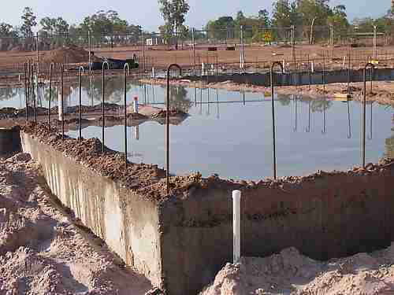
Combining water with a cementitious material forms a cement paste by the process of hydration. The cement paste glues the aggregate together, fills voids within it, and allows it to flow more easily.
Less water in the cement paste will yield a stronger, more durable concrete; more water will give an easier-flowing concrete with a higher slump.
Impure water used to make concrete can cause problems, when setting, or in causing premature failure of the structure.
Hydration involves many different reactions, often occurring at the same time. As the reactions proceed, the products of the cement hydration process gradually bond together the individual sand and gravel particles, and other components of the concrete, to form a solid mass.
Reaction:
Cement chemist notation: C₃S + H₂O → CSH(gel) + CaOH
Standard notation: Ca₃SiO₅ + H₂O → (CaO)•(SiO₂)•(H₂O)(gel) + Ca(OH)₂
Balanced: 2Ca₃SiO₅ + 7H₂O → 3(CaO)•2(SiO₂)•4(H₂O)(gel) + 3Ca(OH)₂

Carbonation in concrete:
Carbon dioxide from air can react with the calcium hydroxide in concrete to form calcium carbonate. This process is called carbonation, which is essentially the reversal of the chemical process of calcination of lime taking place in a cement kiln. Carbonation of concrete is a slow and continuous process progressing from the outer surface inward, but slows down with increasing diffusion depth. Carbonation has two effects: it increases mechanical strength of concrete, but it also decreases alkalinity, which is essential for corrosion prevention of the reinforcement steel. Below a pH of 10, the steel's thin layer of surface passivation dissolves and corrosion is promoted. For the latter reason, carbonation is an unwanted process in concrete chemistry. Carbonation can be tested by applying Phenolphthalein solution, a pH indicator, over a fresh fracture surface, which indicates non-carbonated and thus alkaline areas with a violet color.
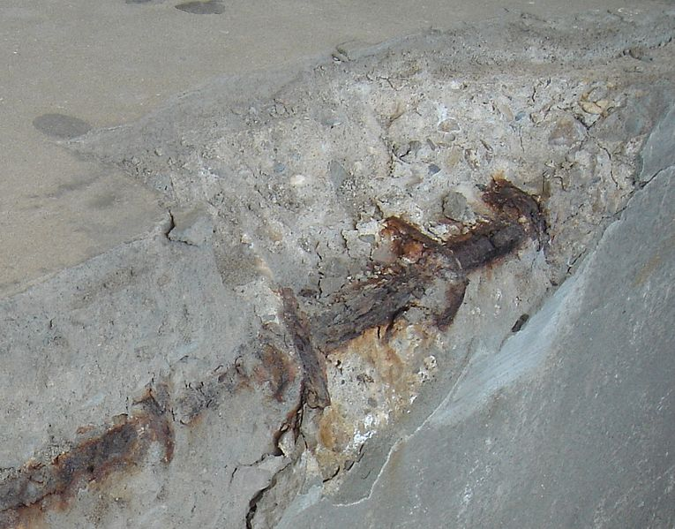
Early stages’ buildings – Brick
Bricks may be made from clay, shale, soft slate, calcium silicate, concrete, or shaped from quarried stone.
Clay is the most common material, with modern clay bricks formed in one of three processes - soft mud, dry press, or extruded.

The soft mud method is the most common, as it is the most economical. It starts with the raw clay, preferably in a mix with 25-30% sand to reduce shrinkage. The clay is first ground and mixed with water to the desired consistency. The clay is then pressed into steel moulds with a hydraulic press. The shaped clay is then fired ("burned") at 900-1000 °C to achieve strength.
For extruded bricks the clay is mixed with 10-15% water (stiff extrusion) or 20-25% water (soft extrusion). This is forced through a die to create a long cable of material of the proper width and depth. This is then cut into bricks of the desired length by a wall of wires. Most structural bricks are made by this method, as hard dense bricks result, and holes or other perforations can be produced by the die. The introduction of holes reduces the needed volume of clay through the whole process, with the consequent reduction in cost. The bricks are lighter and easier to handle, and have thermal properties different from solid bricks. The cut bricks are hardened by drying for between 20 and 40 hours at 50-150 °C before being fired. The heat for drying is often waste heat from the kiln.
