Investigation of the energy release of the butter

see which type of butter can carry out more energy release in order to find out if the fat content of the margarine is really lower than that of the pure creamy butter
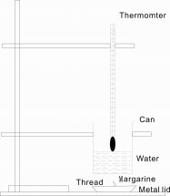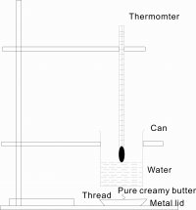
Result:
 | Mass before heating (g) | Mass after heating (g) | Water Temp. before heating (°C) | Water Temp. after heating (°C) | Mass of Water (g)
Margarine | 5.64 | 5.40 | 26.5 | 34 | 62.5
Pure Creamery Butter | 5.65 | 5.29 | 26.5 | 46 | 62.5

By using the formula of E=mcΔT, we can find the energy released (E) of the butter.

(E) of Margarine in three minutes =[62.5g‧4200Jkg^{–1}°C^{–1}‧(34-26.5) °C] / (5.64-5.40)g
=1968750J/0.24g
=8203.125kJ

(E) of Pure Creamery Butter in three minutes =[62.5g‧4200Jkg^{–1}°C^{–1}‧(46-26.5) °C] / (5.65-5.29)g
=5119750J/0.36g
=14218.75kJ

After weighing the mass of both metal lids, we found the mass of lid contains Pure Creamery Butter is less than the one contains the Margarine. That means the (E) of Pure creamery Butter in three minutes is greater than that of the Margarine for burning.

Conclusion:
From the above experiment, we can prove that the energy release (E) of the Pure Creamery Butter is greater than that of the margarine. As the only different between the set up is the type of butter, which contains different fat as animals’ fat and plants’ fat. Therefore, we can know that the energy of animals’ fat is richer than the energy of plants’ fat.

