You can also make your own bathing soap simply by following this recipe. Work it out!

Basic Bath Bomb Recipe  Gather your ingredients:  • 1 part citric acid  • 2 parts baking soda  • Witch hazel  • Coloring of your choice  • Fragrance oil of your choice  • Dome Shaped Mold | 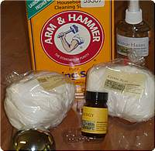

 | 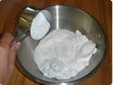 | BLEND BLEND BLEND BLEND the citric acid and baking soda – this step is super important – if you don’t blend well, you end up with a grainy bomb. We actually use a mixer on our larger batches.

 | 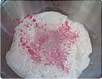 | Once you’ve blended really well, add your colorant. Dry pigments or a specialty bath fizzy colorant like La Bombes work best – don’t add too much though – the color shows up once you add the witch hazel.

 | 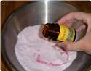 | Add fragrance oils to your personal nose preference.

 | 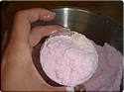 | Now, this is the difficult part. Spritz (with a squirt bottle) the witch hazel onto your batch while stirring with the other hand. When your batch sticks together when squished, you need to start putting it in molds – time is of the essence. If you wait too long, the mixture will get hard. If you spritz too much, the mixture will be too wet and “grow” (start the fizzing reaction) on you.

 | 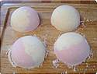 | Put the bombs in molds – wait a few minutes and tap them out. Let them air dry for 3 or 4 hours and voila! Wonderful, hard bath bombs. The harder you pack the bath bombs, the more dense, heavy, and durable bomb you will get.

