Acid destroys the nutrients in milk.
The protein in milk is solidified.
Then, would there be any chemical reactions between acid and the glucose in apples?
Let's look at the result below.

Result:
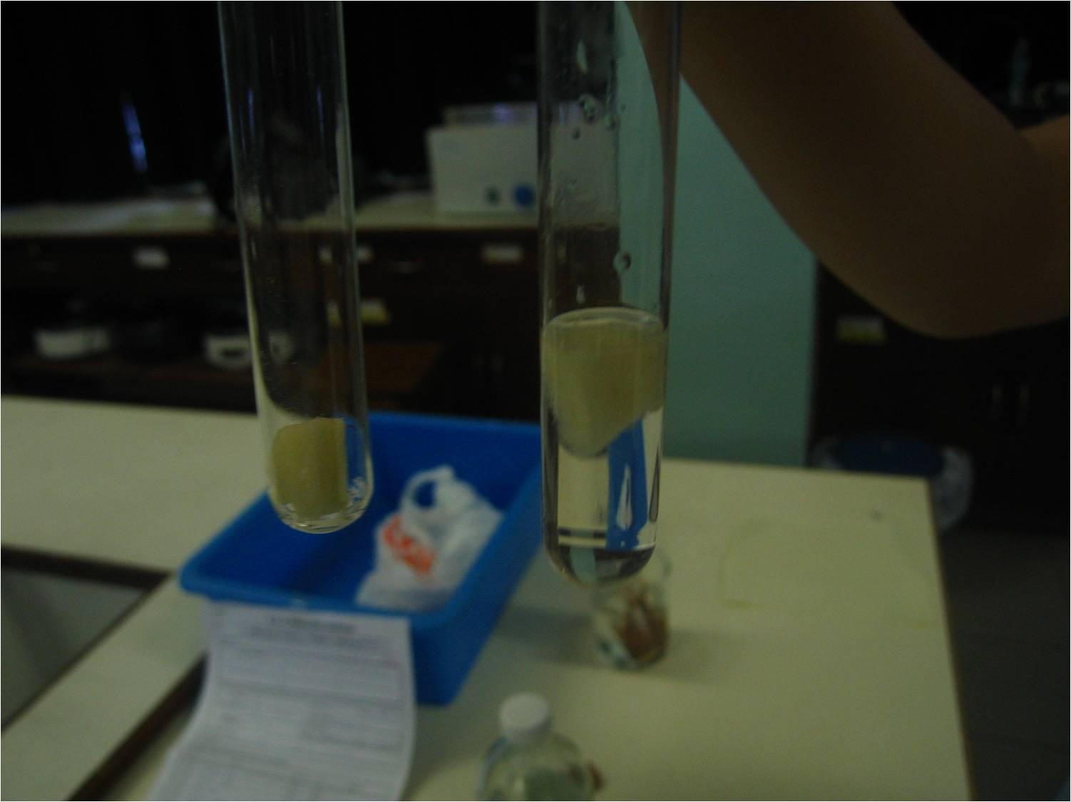
 | Apple | Apple with vinegar
Amount of glucose | ++ | +++
Colour change | Pink to purple | Pink to dark purple
Conclusion:
- The amount of glucose doesn't reduce as the vinegar is used as a preservative. It usually would not destroy the nutrients in food except proteins.
- The sugar in the vinegar causes an increase of the amount of glucose in apple.
- The apple immersed in the vinegar does not get rust while the other apple dose.

In our daily life:
Vinegar can preserve food. It usually can keep the food for a longer time without destroying the nutrients (except protein) in food.

