Phy – Act of physics Chan Wai Kun (5)

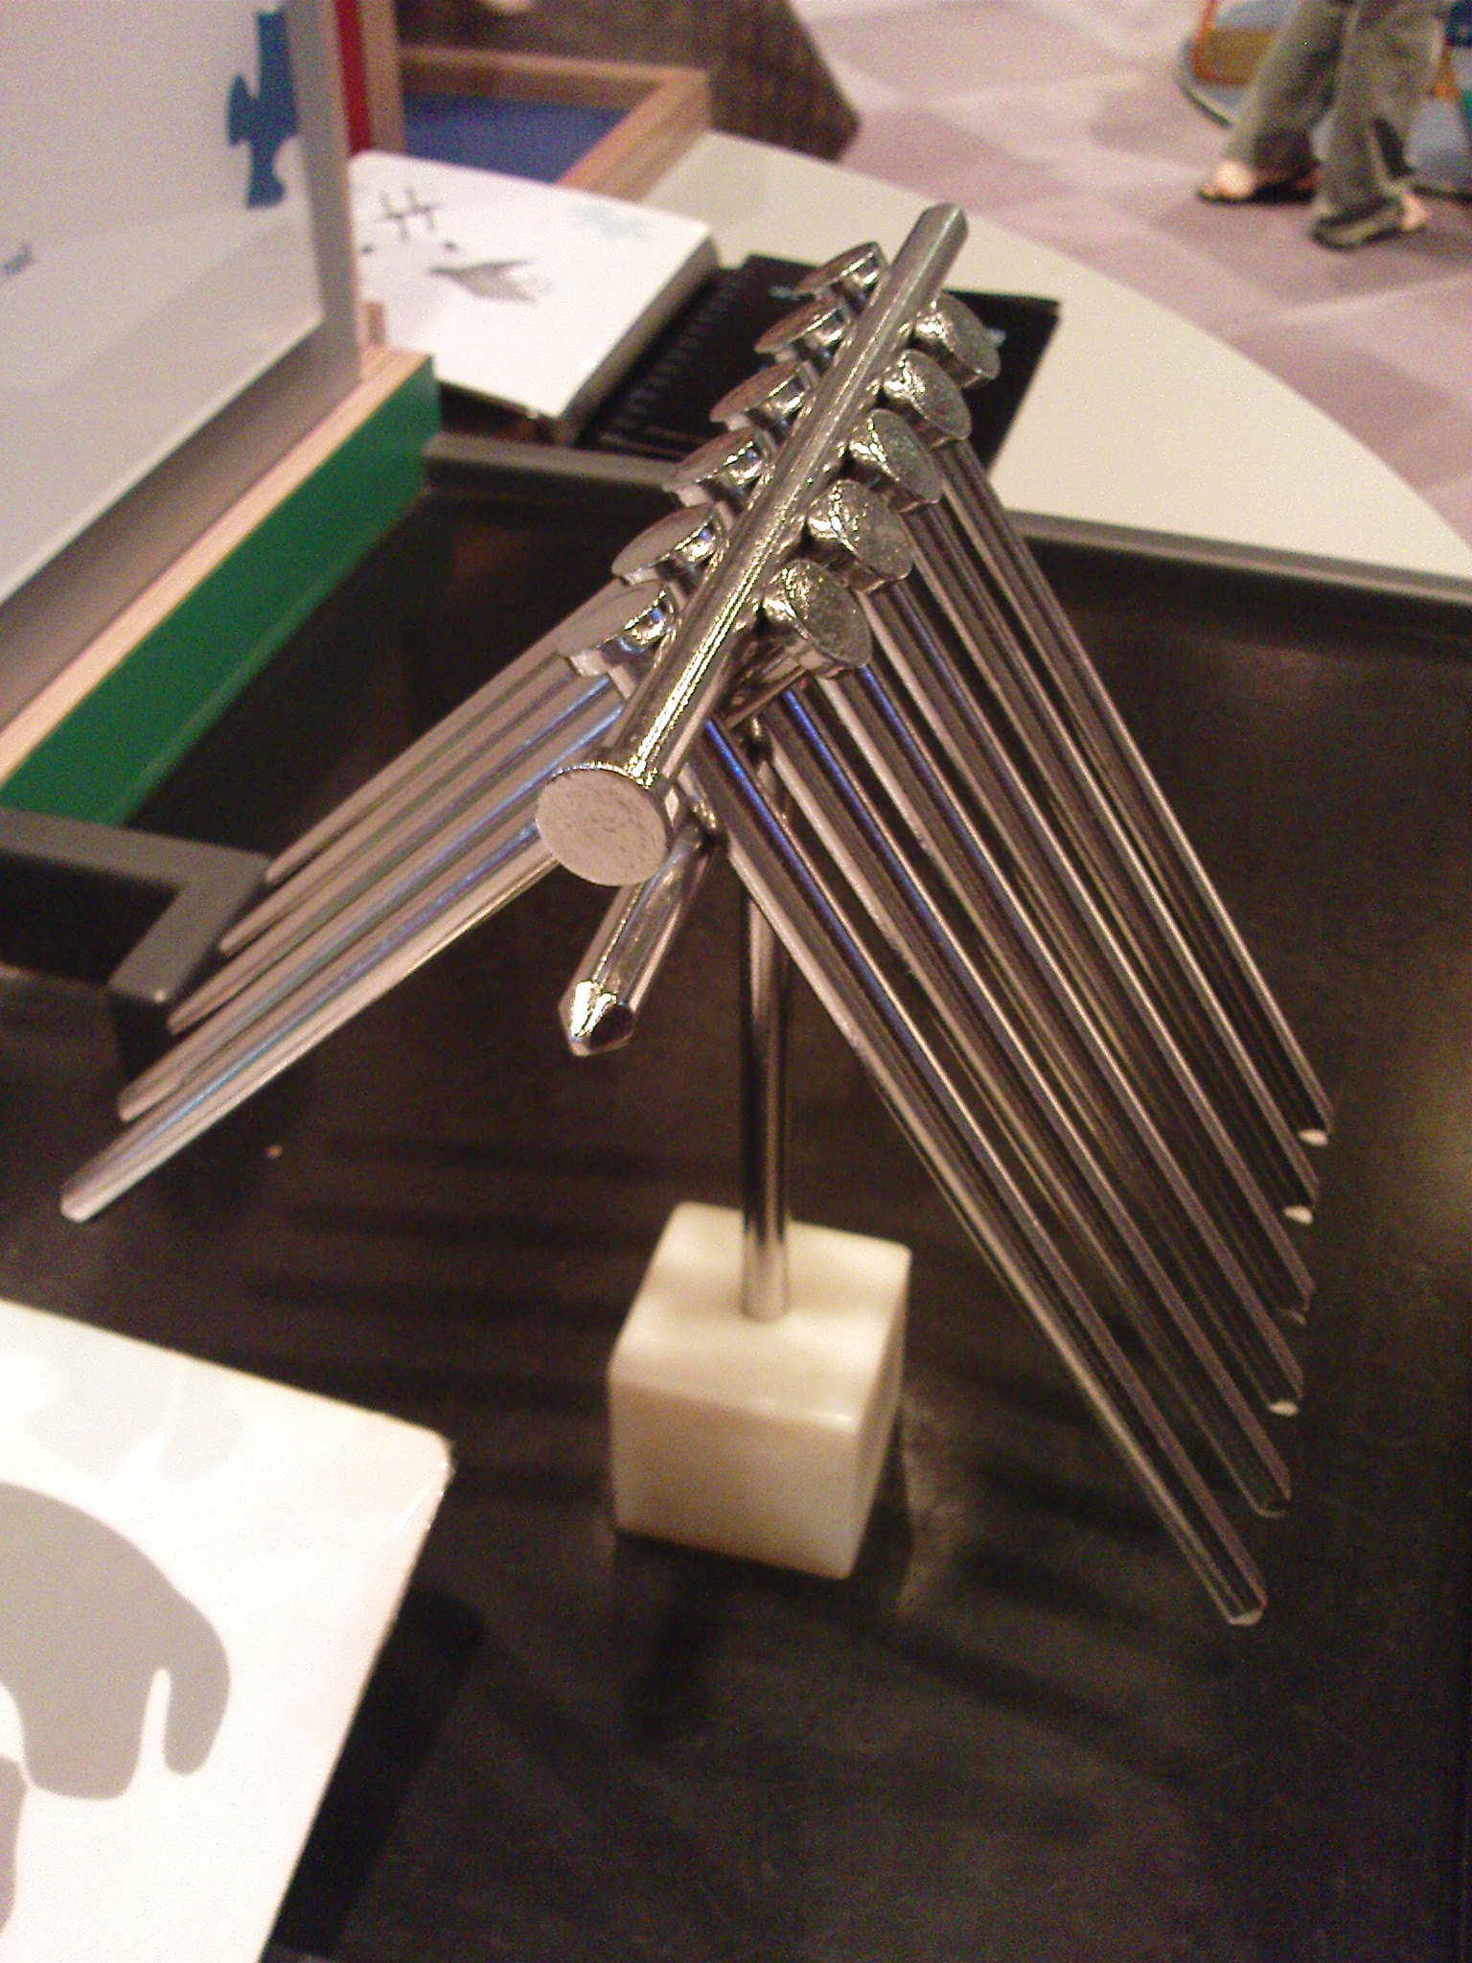
It was a nice experience to visit the Science Museum. We looked at many breath-taking exhibits. The most unforgettable one is that we have to think of the way to hold 14 metal rods with a little block as shown in the picture. A few of us worked together but failed to figure out how to make it! After looking at the answer, we were all astonished. The art of physics is really marvelous but hard to understand! We might not have come across many items “in the syllabus”, but I do think it is worthy to spend time on the visit. It indeed enhanced our interest in science and gave 7S students precious memories.

Chan Wai Kun (5)

Bio – Lufengosaur Ng Man Yee (20)

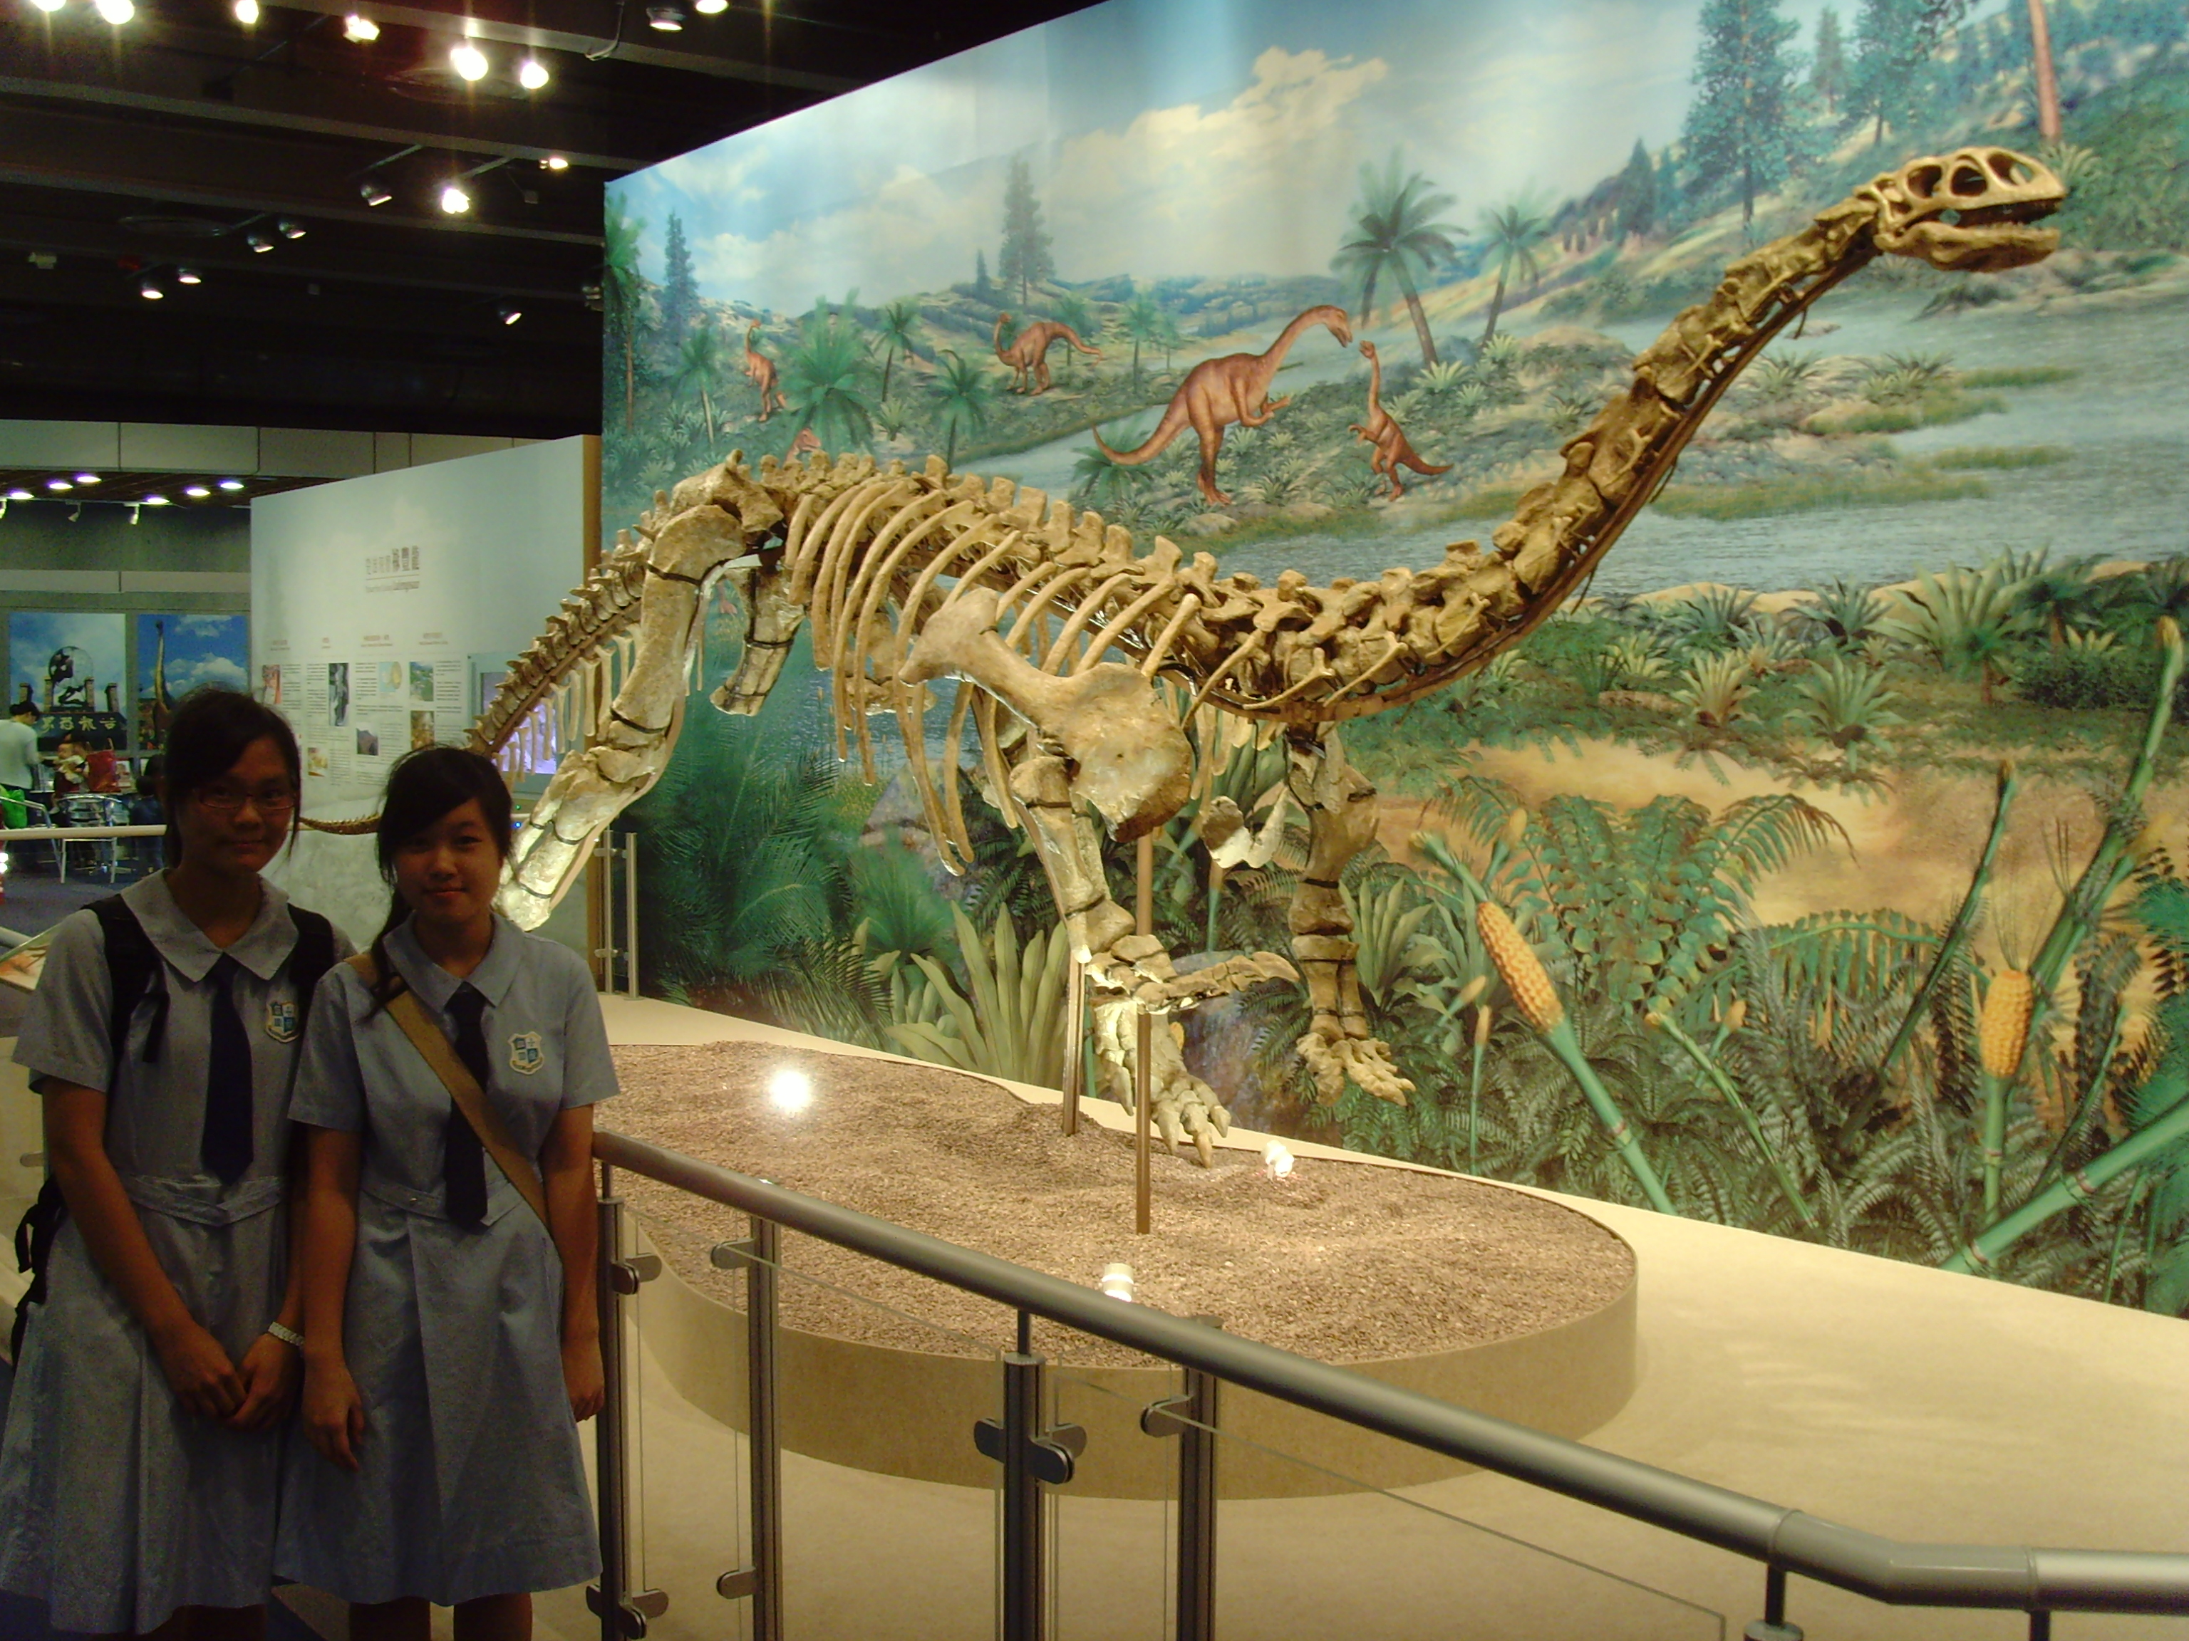
On 5th November, we have been to ‘Science Museum ‘. It is a great experience to be explored in the world that full of science. I am so amazed when I was there looking at the Lufengosaur skeleton displayed at the entrance of the museum. Having such excitement, I am really looking forward to have a look inside the museum. We played around and tried every set-up there. What I remember most are the fitness test as well as the part about illusion, those pictures are really fascinating. I enjoyed looking at the photos and having a sense of confusion which can lead me to an imaginary world. Learning is not just from school and textbooks, but also from our daily life. The visit to the science museum is invaluable which encourage us to learn not just from school, but by ourselves.

Ng Man Yee (20)

