So Chun Yan 7S (20) The Deep
A visit to Hong Kong Science Museum

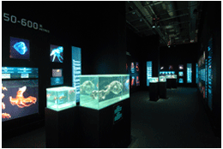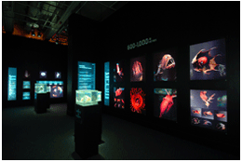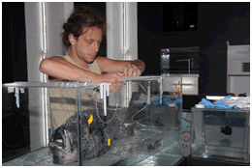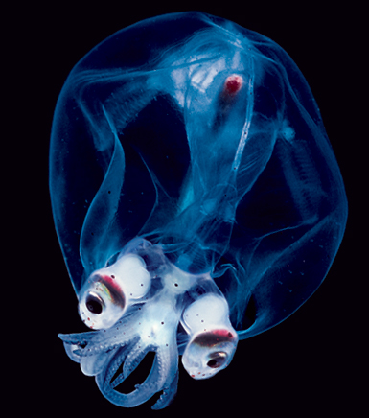

Exhibit chosen: The Deep

Introduction:

Oceans cover about 71% of the Earth's surface area, but in terms of volume, they make-up 98% of the habitable space on the planet. Without question, the majority of life on Earth lives in the seas. Yet, for all that scientists have learned thus far, we have only just begun to scratch the surface of what the oceans have to teach us. The exhibit shows us the marine animals hidden away in depths, with specimen and photos; we can understand how they adapt to the tough environment—lack of food sources, low temperature and low light intensity.

Commentary:

There is so much we can learn from this visit, the majority of specimens presented in the exhibition are very rare animals that can hardly be obtained because they live over1000m under the sea level. We seldom have a chance to contact marine animals other than fishes or shrimps for daily consumption, not to mention those living in deep seas. Through observing the specimen and photos as well as watching video clips, I gained a better understanding of the adaptations and biology of marine animals. This valuable experience definitely widens my horizon!

