AL Chemistry
Name: _Chan Ka Chun ______ ( 2 ) Form 7S
Name: _Koo Yat Kwan ______ ( 13 ) Form 7S
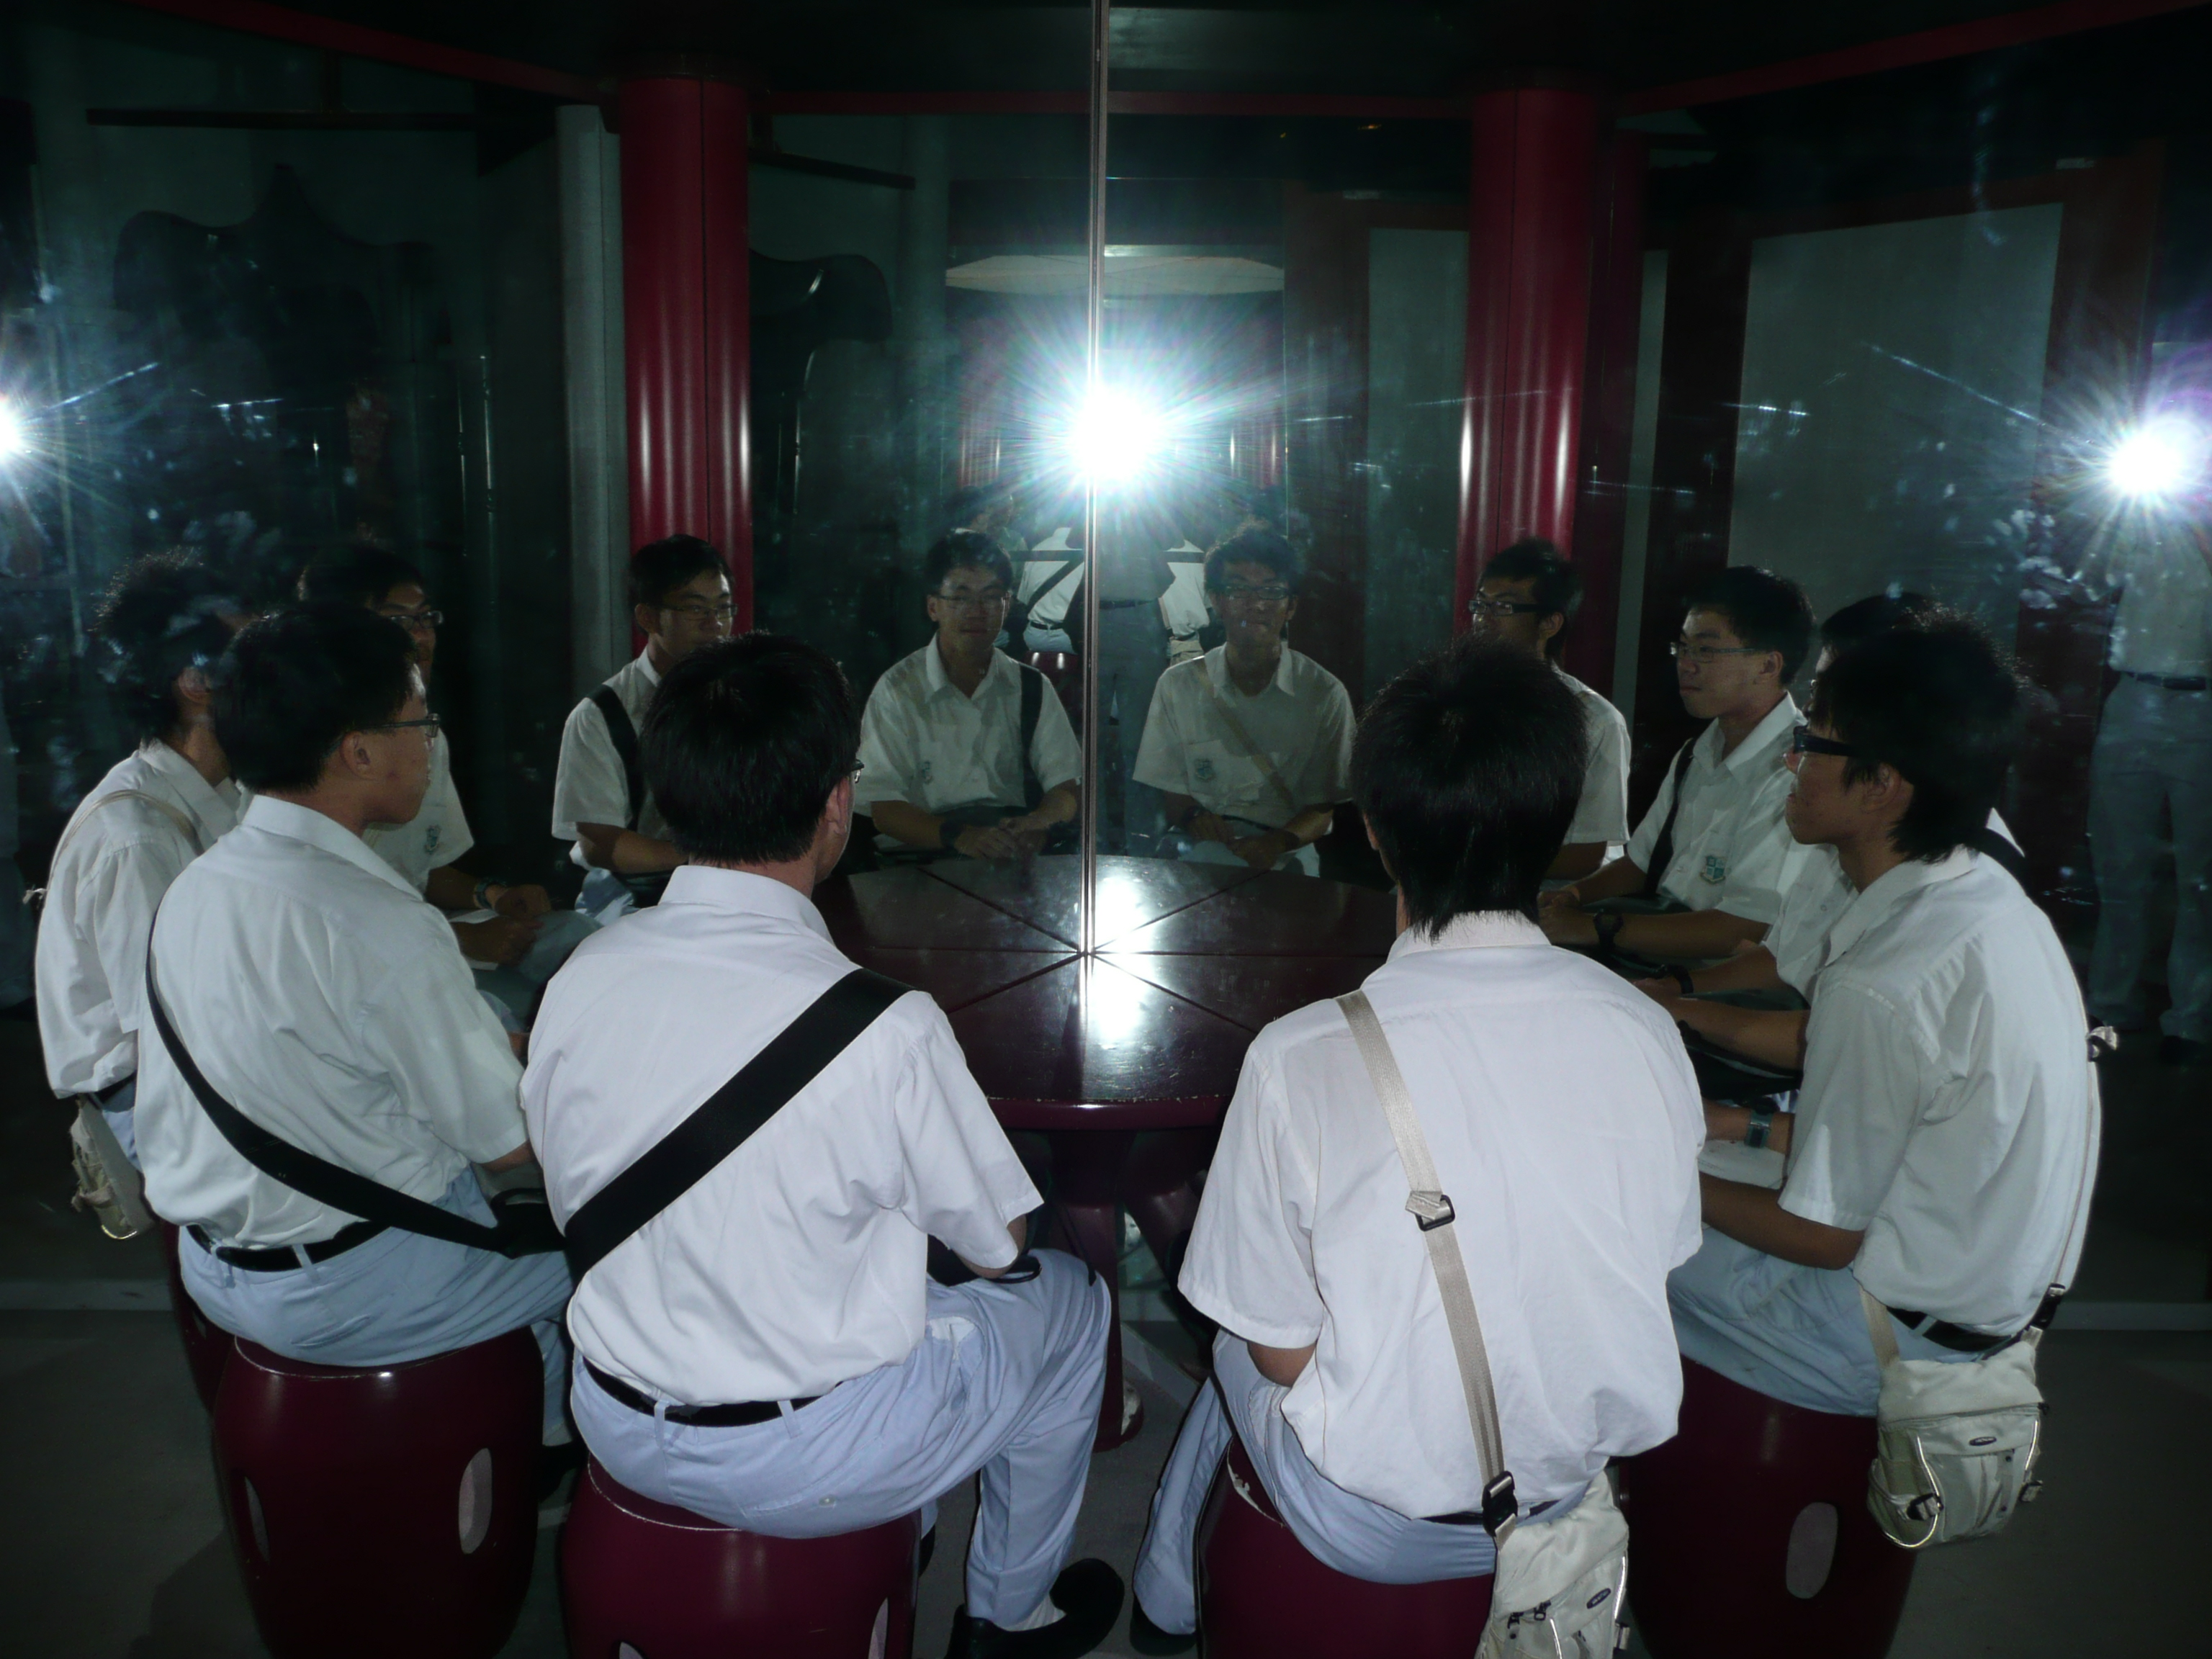

Comment: This exhibition uses the principle of reflection to produce images of the sitters. In the photo, only two students are sitting in front of the table with two mirrors. Through the mirror, ten images are formed.
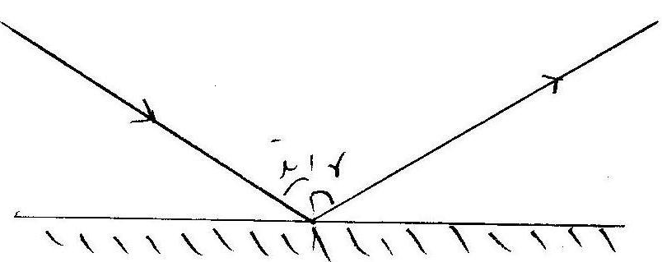

This is the Law of Reflection. The angle of incidence is equal to the angle of reflection and the reflected light is co-planar with incident light ray. The real image is produced by the extrapolation of the reflected light. The image is equidistance to the mirror with the object.
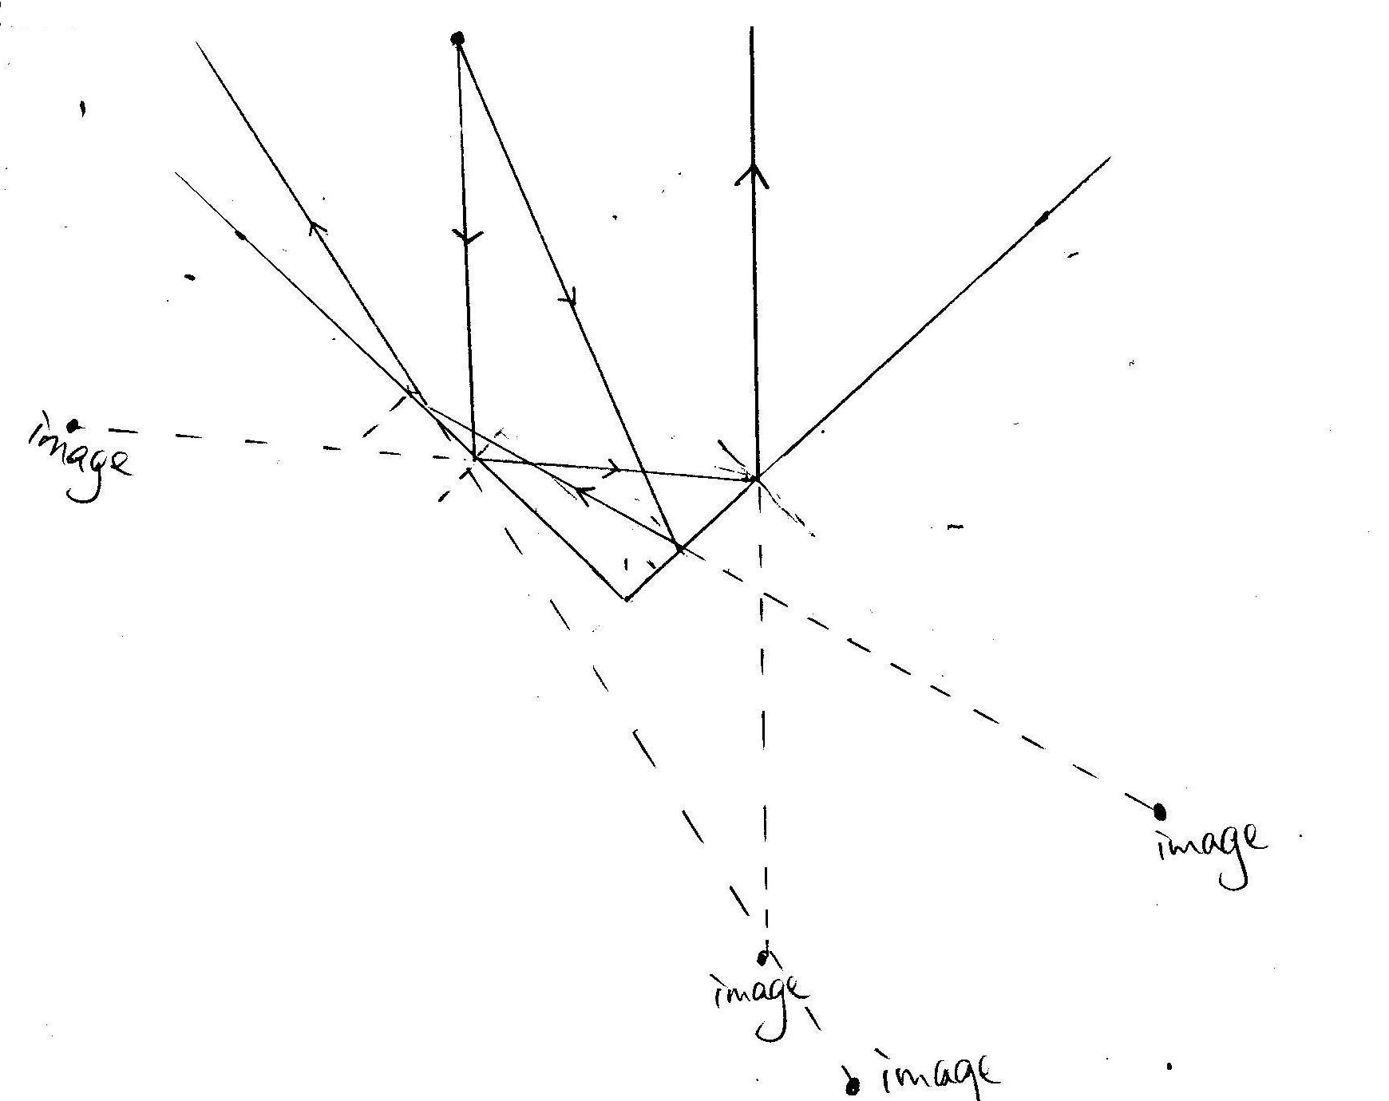
In this graph, four images are produced by the reflection of two light rays with two mirrors. The real case is more complicated and more images can be formed.
The series of works are placed in an area named as Maze of Mirror. The routes inside are somehow confusing, with walls made of mirrors so we would mistakenly think that there is road ahead until we crash into the mirror with our painful noses. This realizes us there are numerous fakes and traps in our daily lives, especially when we lapse into the heartless society in the future, if we are not careful enough, we will be easily trapped by the enemies, leading to a painful result. Nevertheless, we get fun in the Maze of Mirror when we see different interesting works made by mirrors causing illusions.

