Science Museum (Chemistry)
7S Chan Wai Shan(6) Hui Ling Chui(10)
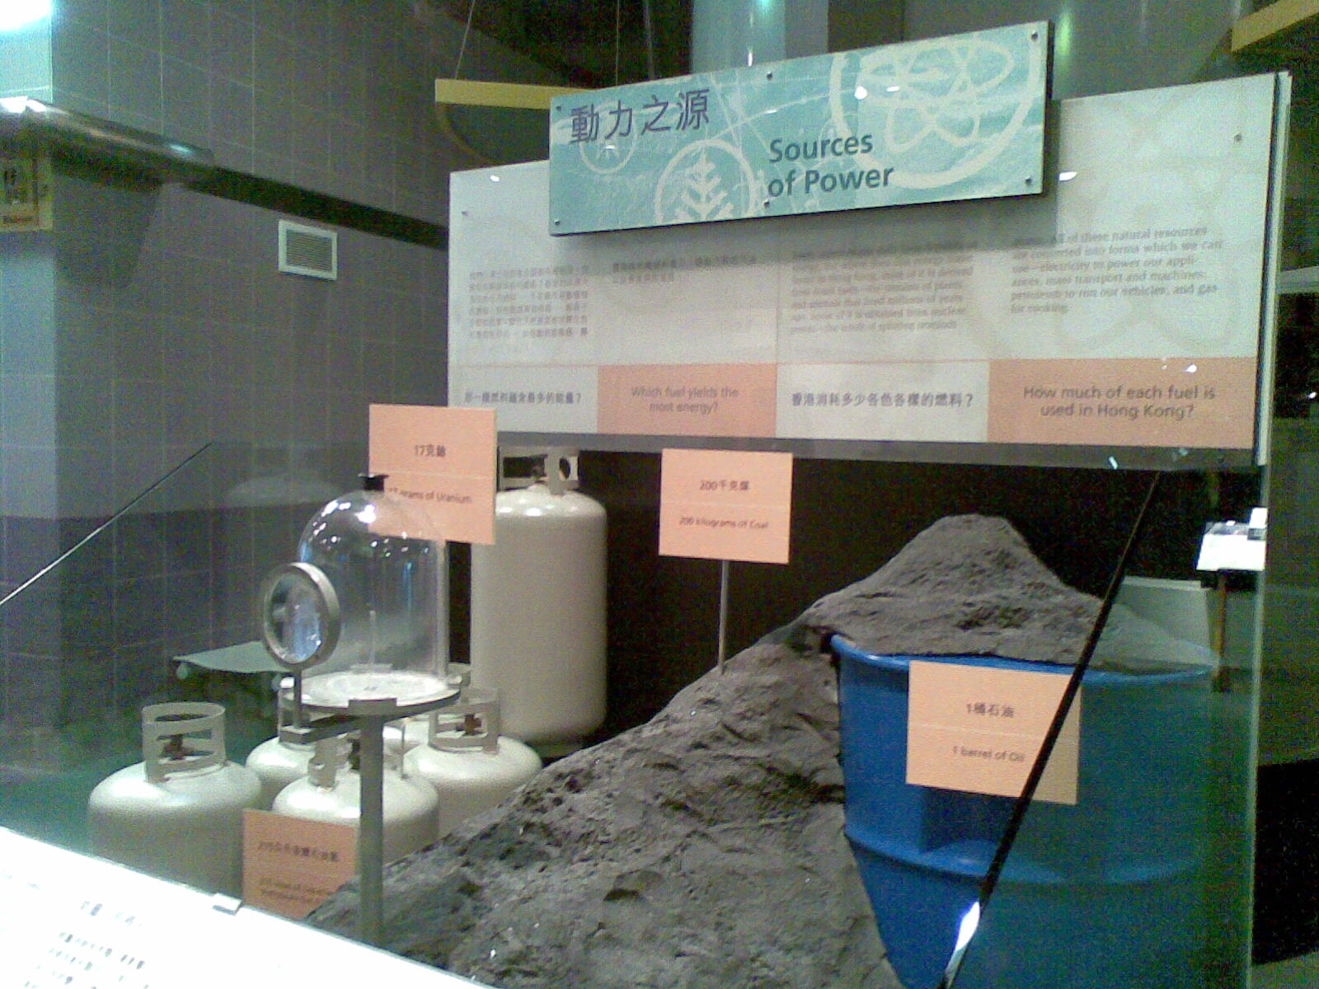

We learn a shocking fact in one of the exhibits in Science Museum called “Sources of energy”. Do you know how much electricity can be generated by a small piece of 17g Uranium? That’s equal to the amount generated by 200kg of coal, 215L of liquefied petroleum gas as well as 17g of Uranium!
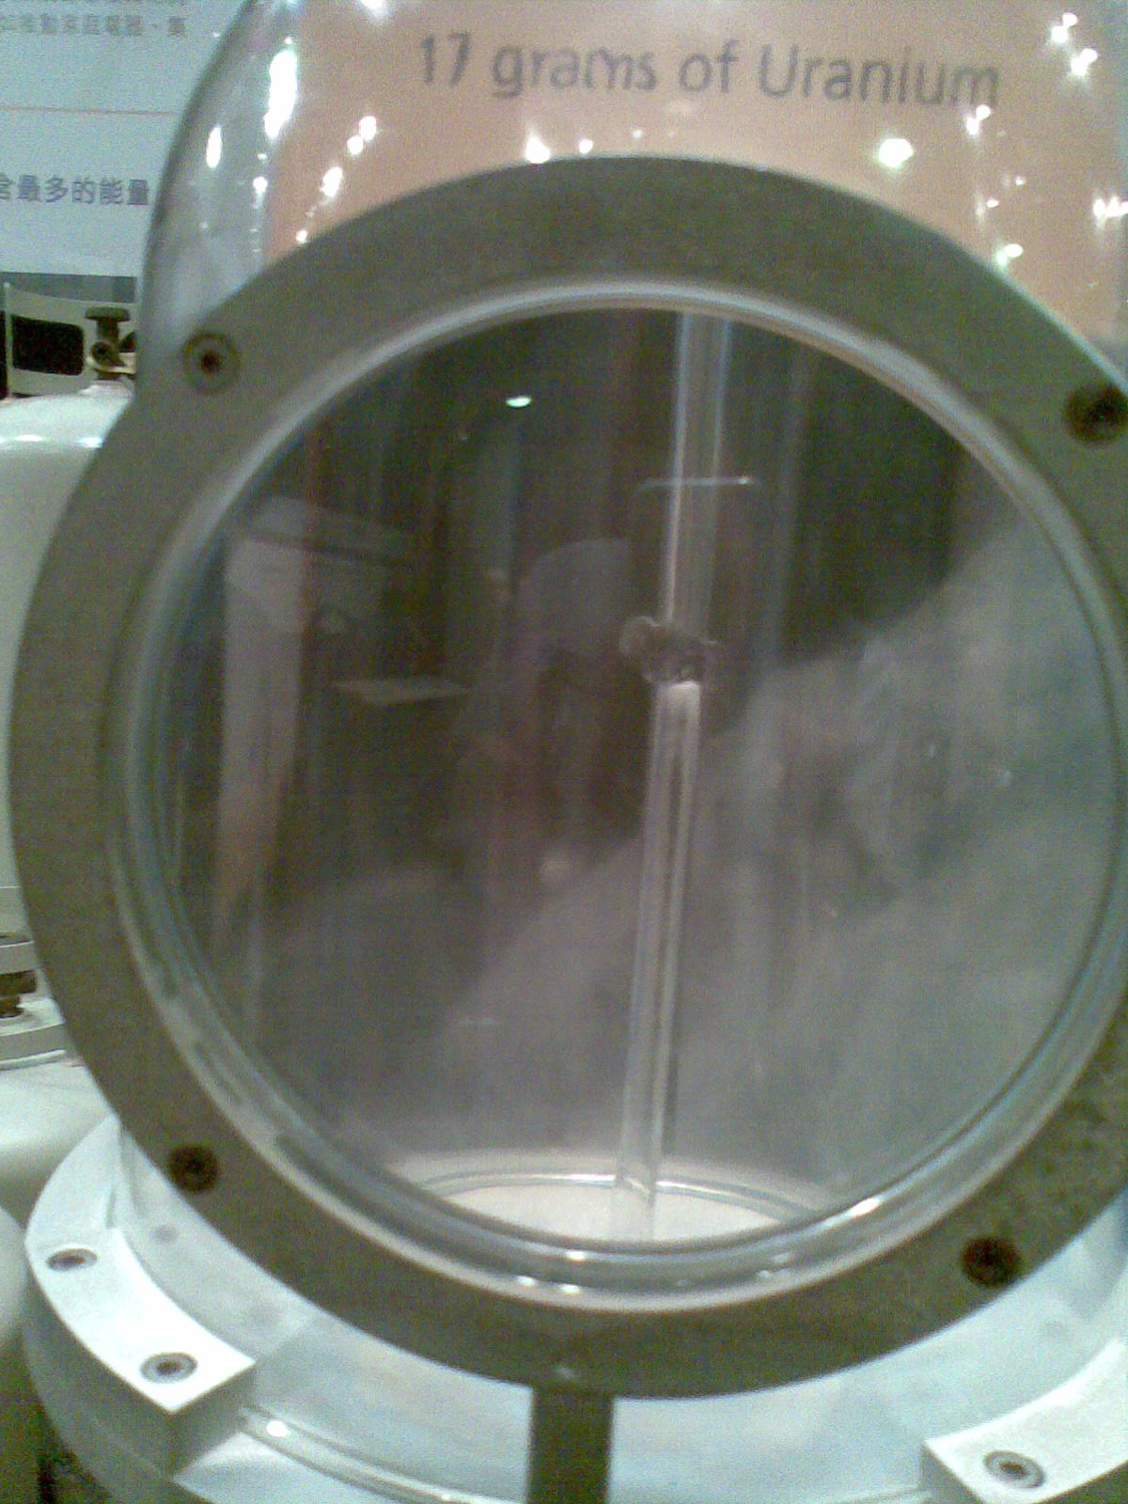
Uranium is a silvery-gray metallic chemical element which is slightly radioactive in the actinide series of the periodic table with a atomic number of 92. It is a fuel of the nuclear power plant. Below is the chemical equation of the nuclear reaction (decomposition of ²³⁵ ₉₂U):

¹₀n + ²³⁵ ₉₂U ---> ⁹²₃₆Kr + ¹⁴¹₅₆ Ba +200 MeV+ 3 ¹ ₀n

The use of Uranium in power plants has its own advantages. The most important one is that it reduces world’s dependence of fossil fuels, which in turn decreases the carbon dioxide emitted from them. Also, the cost of nuclear power isn't affected by fluctuations in oil and gas prices. However, nuclear waste produced from the process is still radioactive and destructive to organisms. It takes at least hundreds of year for the waste to decay to the safe level. Therefore, it must be well treated during this long period. And this contributes to the high cost of generating nuclear power.

