Hong Kong Science Museum (Chemistry) Chemical Cell

Name: Tang Chun Kit 7s (21)
Leung Joe Yik 7s (16)

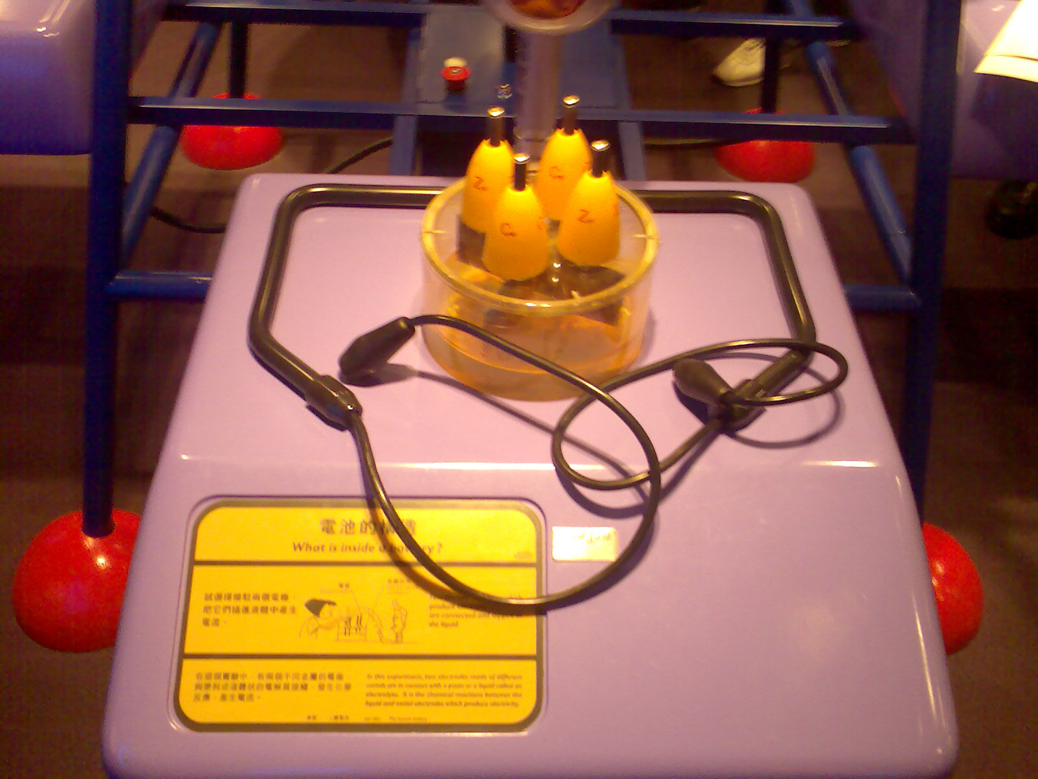

Reflection:
Amid the visit, we have learnt quite a lot and have found the Hong Kong Science Museum interesting. In the exhibition, there are numerous of applications concerning such subjects which we have studied as chemistry, physics and biology.
In the above photo, it is a demonstration about a chemical cell. Just as what we have learnt, it makes use of the electric potential produced when two different materials are immersed into electrolyze. Given the electric potential, a steady current is induced and therefore switch the light bulb up. Although the demonstration is simple, it teaches people to choose correct materials in cathode and anode and it definitely can raise the interests of the others to learn more about science.
We are so glad to have the chance of having a visit and convince other students can feel the same way and benefit a lot in the visit.

